# REVIEW activity

**APPROACH**

**OBJECTIVE**: Remember everything seen so far.

**STATEMENT**: Solve the following sections.

We want a database management system for a hospital. We need to store the information for each of the hospital admissions, indicating the patient and the doctor who authorizes it. Based on the data analysis, we have the following conceptual model represented by a UML class diagram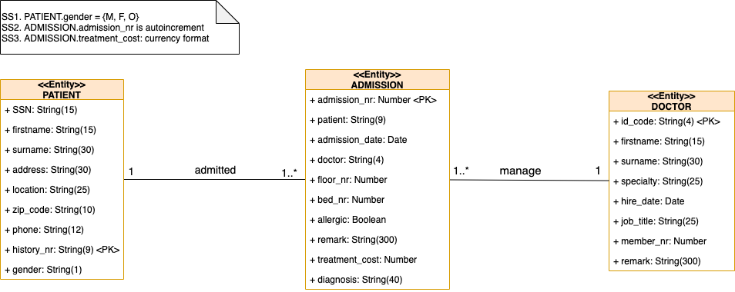.

* Create the database in MySQL taking into account the previous conceptual model.
* Generate the relational model through "Reverse Engineer" of Workbench.
* The sample data you have to enter is:

**PATIENT**

|  |  |  |  |  |  |  |  |  |
| --- | --- | --- | --- | --- | --- | --- | --- | --- |
| **SSN** | **firstname** | **surname** | **address** | **location** | **zip_code** | **phone** | **history_nr** | **gender** |
| 08/7888888 | Matthew | Jackson | 123 Oxford Street | London | W1D 1AA | 07903 123456 | 10203-F | M |
| 08/7234823 | Brandon | Anderson | 456 Covent Garden | London | WC2E 8RF | 07902 654321 | 11454-L | M |
| 08/7333333 | Lauren | Taylor | 789 Sefton Park Road | Liverpool | L17 6AB | 07803 112233 | 14546-E | F |
| 08/7555555 | Sarah | Johnson Castells | 246 Mathew Street | Cardiff | L2 6RE | 07888 13579 | 15413-S | M |

**ADMISSION**

|  |  |  |  |  |  |  |  |  |  |
| --- | --- | --- | --- | --- | --- | --- | --- | --- | --- |
| **admission_nr** | **patient** | **admission_date** | **doctor** | **floor_nr** | **bed_nr** | **allergic** | **remark** | **treatment_cost** | **diagnosis** |
| 1 | 10203-F | 2009-01-23 | KBR | 5 | 121 | 0 |  |  | Epileptic |
| 2 | 15413-S | 2009-03-13 | JSC | 2 | 5 | 1 |  |  | Allergic to penicillin |
| 3 | 11454-L | 2009-05-25 | JSC | 3 | 31 | 0 |  |  |  |
| 4 | 15413-S | 2010-01-29 | OLE | 2 | 13 | 0 |  |  |  |
| 5 | 14546-E | 2010-02-24 | KBR | 1 | 5 | 1 |  |  | Allergic to Paidoterin |

**DOCTOR**

|  |  |  |  |  |  |  |  |
| --- | --- | --- | --- | --- | --- | --- | --- |
| **id_code** | **firstname** | **surname** | **speciality** | **hire_date** | **job_title** | **member_nr** | **remark** |
| JSC | Jane | Smith Codina | Family doctor | 1994-09-23 | Chief | 1331 |  |
| KBR | Kevin | Brown | Paediatrics | 1982-08-12 | Assistant | 2113 | His retirement is near |
| OLE | Olivia | Lee | Psychiatry | 1992-02-13 | Section chief | 1231 |  |

* Write the following queries:
  1. First name, surname and hire date of the hospital's paediatricians.
  2. Name and surname of patients resident in the capital London.
  3. Full name of the doctors who authorized admission between January and February 2010.
  4. Full name and Social Security number of all patients.
  5. Full name of the patients who were admitted between January and May 2009 and are allergic.
  6. Floor and bed numbers where the Liverpool patients were admitted.
  7. Patients whose admission has been authorized by Dr. Kevin Brown.
  8. Full name and telephone number of the patients admitted in 2010.
  9. Full name of the admitted patients suffering from epilepsy.
  10. Full name and date of admission of those patients who have been attended by a psychiatrist.

DELIVER:

* File .sql with all sql statements you need to solve the activity. Separate with comments every section and every query.
* An image of the relational model you have generated.
* Pdf with screenshots of every query showing all your Workbench window, that is, schemas on the left and, script, "*Result Grid*" and "*Action Output*" on the right.